Lab chapter 7
- Graph Coloring (Minimum Colors using Greedy Algorithm)

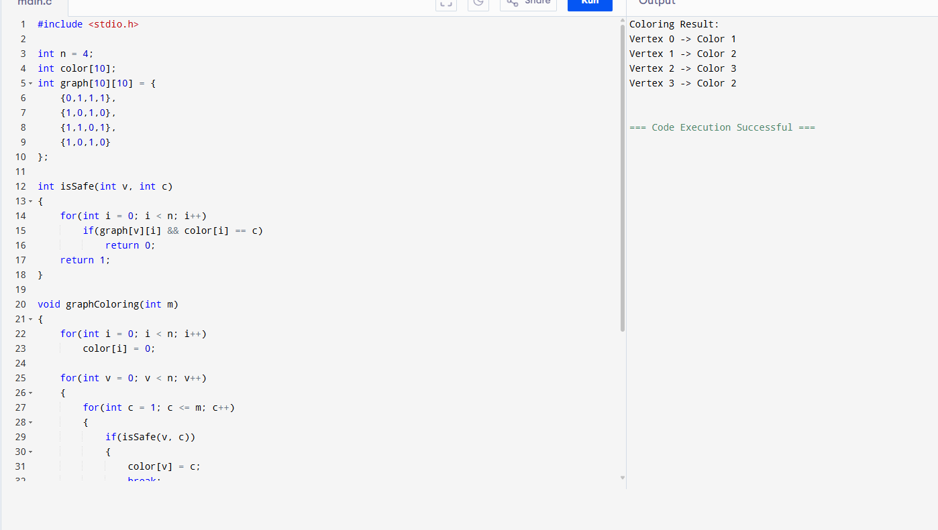
2. Maximum Regions Colored in Turn-Based Graph Coloring
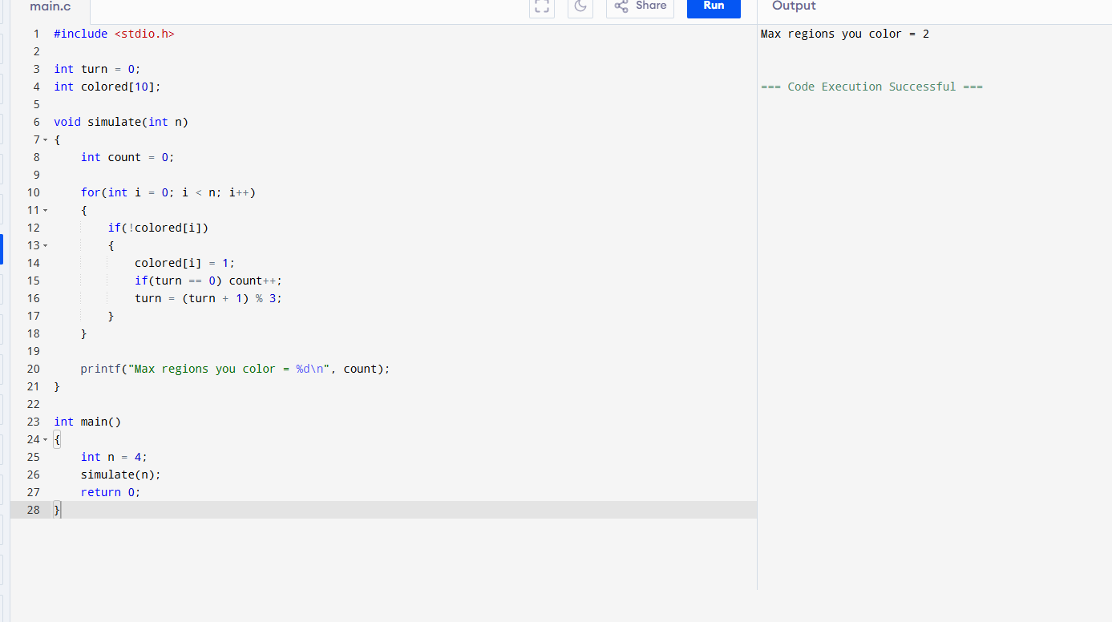

3. Hamiltonian Cycle Detection (Graph Backtracking)
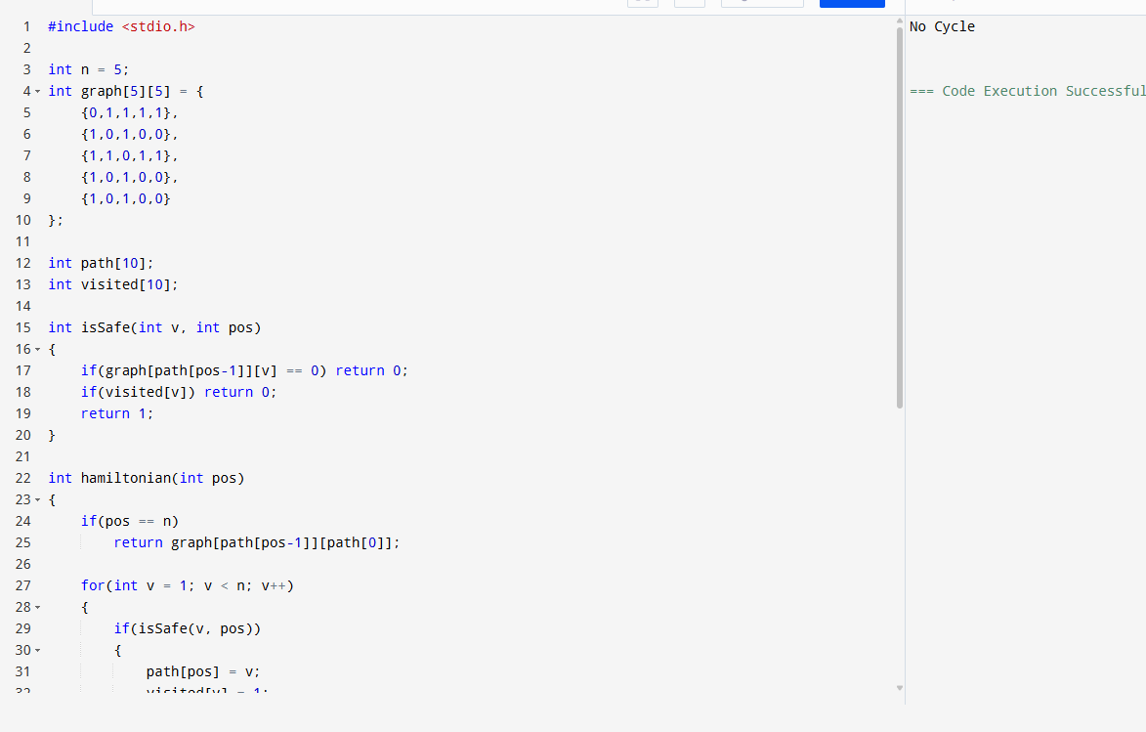
4. Hamiltonian Cycle Detection (Alternative Case)
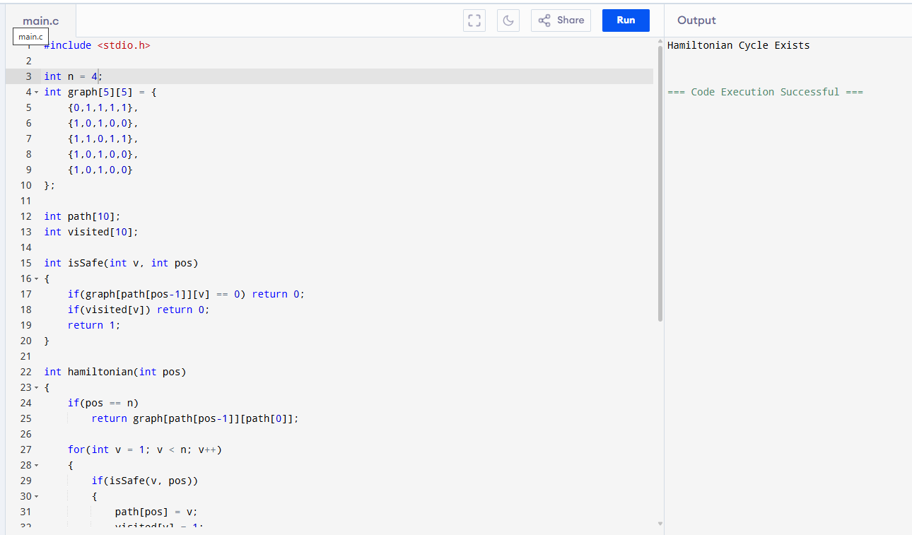

5. Subset Generation (Power Set)
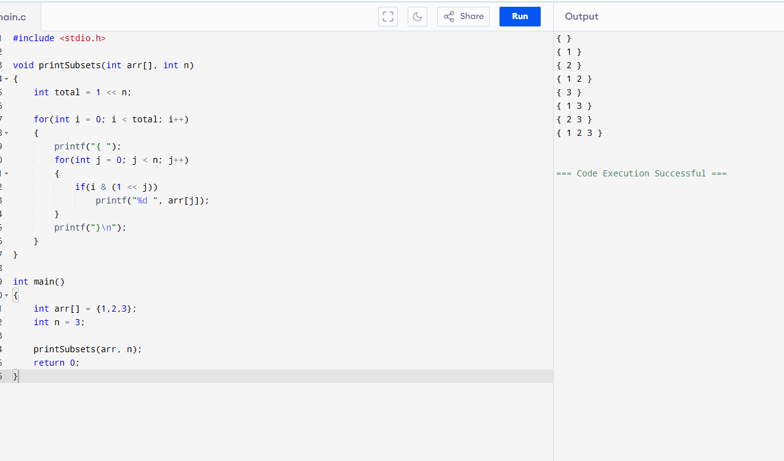
6. Subsets Containing a Specific Element
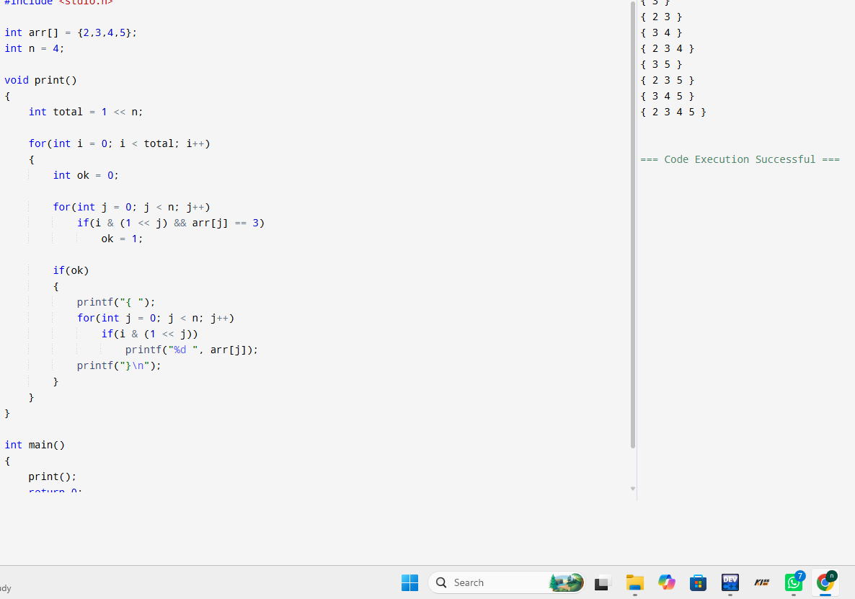
7. Universal Strings Problem (Words Subset Check)